

**A CRM Application to Manage the Services offered by an Institution**

College: 7155 - PSG Institute of Technology and Applied Research

Team ID: NM2024TMID00692

Team Lead: **GOKUL S - C9E61467E1C58B9A9BA478CF3697FA2D**

Team Members:

| HARISHRAM S | 9A1A4C81FAEDD9389FB4B690C85296E9 |
| --- | --- |
| ROHITH SHANKAR V | 2EC98B95166A8318D4B43B362943DF11 |
| MUGUNTHAN R | BD37296B04E4ABFB89E45B98BFD833DF |
| THULSERAM NAIDU K B | DF14153DBCEAC8B87EF4486FE19140B0 |

1. **Project Overview**

This CRM (Customer Relationship Management) application leverages Salesforce to streamline and centralize service management processes for an educational institution, supporting a seamless experience for prospective students, admissions staff, consultants, and case managers. The primary objective of this project is to provide a unified platform that efficiently handles admissions, consulting services, and immigration cases, thus enhancing the institution’s service delivery and operational efficiency.

1. **Objectives**

**Business Goals:**

* Streamline institutional processes to enhance efficiency and reduce manual tasks.
* Improve the student experience by offering fast, transparent service through automation.
* Leverage data insights for informed decision-making and secure, compliant operations.

**Specific Outcomes:**

* Automated admissions, consulting, and case management increase process speed and staff productivity.
* Custom reports and dashboards provide real-time insights into application, consulting, and case metrics.
* Optimized workflows and approval processes ensure timely responses and clear student communication.
* Enhanced data security and compliance foster trust, protecting sensitive student information.

1. **Salesforce Key Features and Concepts Utilized**
2. **Custom Objects**: The project includes custom objects like "Admission Application," "Consulting Request," and "Immigration Case." For example, each student’s admission form submission generates an “Admission Application” record, capturing essential information like academic history and contact details, and making it accessible to admissions staff.
3. **Standard Objects**: Standard Salesforce objects like "Contact" and "Account" are used to store each student's profile and link to their applications or requests. This allows admissions and consulting staff to access a student's complete record and track their interactions with the institution.
4. **Relationships**: Master-detail and lookup relationships link records across these objects. For instance, each Consulting Request is linked to a Contact record (the student), enabling consultants to view the specific needs and background of the student requesting assistance.
5. **Automated Approval Workflows**: The CRM system uses an approval process for reviewing and approving "Consulting Requests." When a consulting request is created, it’s automatically routed to the relevant advisor for approval, ensuring a streamlined workflow and avoiding delays.
6. **Email Alerts**: Upon approval or rejection of a consulting request, students receive an automated email notification updating them on the request’s status. This ensures students are kept informed without manual follow-up from staff.
7. **Automatic Submission**: Consulting Requests are automatically submitted to the approval queue upon creation, reducing manual intervention and speeding up the review process for advisors.
8. **Workflow Rules**: Workflow rules automatically send email alerts when students submit admission or consulting requests, keeping them informed of receipt and status. This automation minimizes the need for staff intervention in sending updates.
9. **Process Builder**: Process Builder is used to automate specific steps, such as changing the status of consulting appointments from "Scheduled" to "Completed" after the appointment date has passed, keeping records up-to-date.
10. **Flow**: Flows manage more complex processes, such as automatically updating case records when a student’s admission status changes, notifying the admissions team if specific criteria are met, and generating follow-up tasks to ensure all steps are handled.
11. **Email Alerts**: Automated email alerts are configured to send confirmation messages upon successful submission of an application, consulting request, or immigration case. For example, when an immigration case is submitted, the student and case manager are notified, helping keep all parties updated.
12. **Case Object**: The standard Case object is customized to handle and track immigration cases. When a student initiates an immigration case, a record is created with details like the nature of the case and relevant documentation. This enables immigration agents to access and manage all case information in one place.
13. **Role Hierarchies**: Role hierarchies are configured so that admissions officers, consultants, and case managers have access only to the records relevant to their roles. For example, admissions staff can view student applications but not consulting or immigration records, ensuring data security.
14. **Permission Sets**: Permission sets grant special access to specific users, such as allowing external consultants to access only consulting request data. This controlled access ensures each user sees only the information they need.
15. **Field-Level Security**: Sensitive student information is restricted based on user roles, ensuring compliance with privacy policies. For instance, only immigration agents can access fields containing confidential case details.
16. **Detailed Steps to Solution Design**

* **Created the Course Object**

The Course object was designed to store detailed information about courses offered by the institution, including fields for course name, description, and duration.

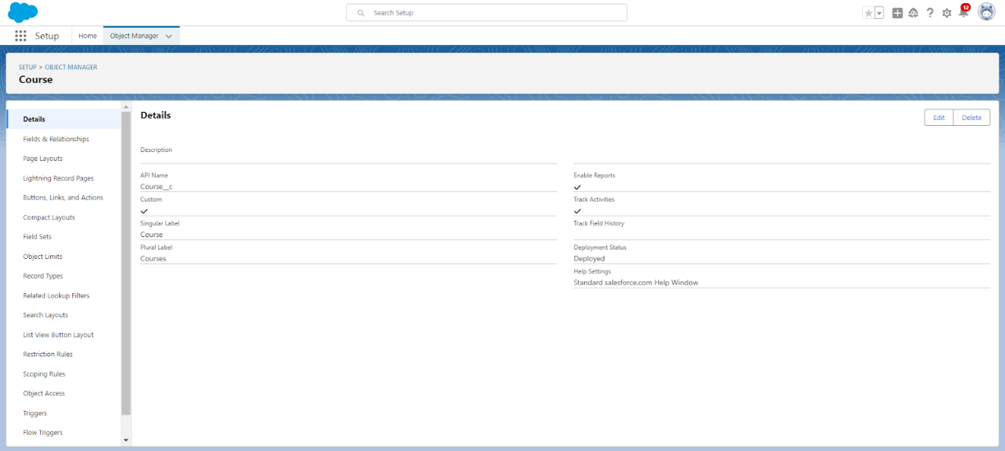

* **Created Remaining Objects**

Additional objects such as Student, Registration, Appointment, and Immigration Case were created to represent different service areas within the institution and manage related data efficiently.

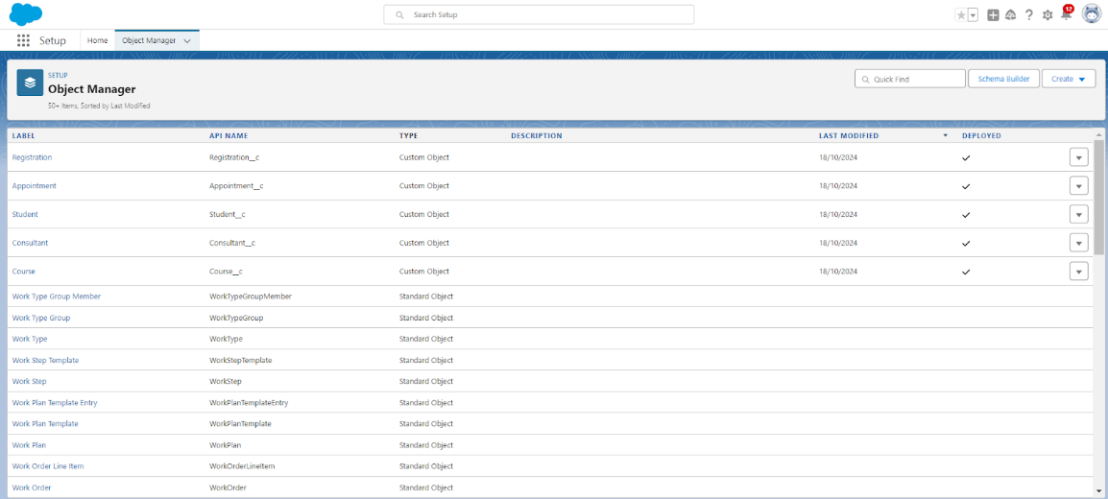

* **Established Relationships Among Objects**

Relationships were defined among Course, Student, and Registration objects to link students with their enrolled courses. Lookup and master-detail relationships ensured data integrity and connected records logically for ease of access.

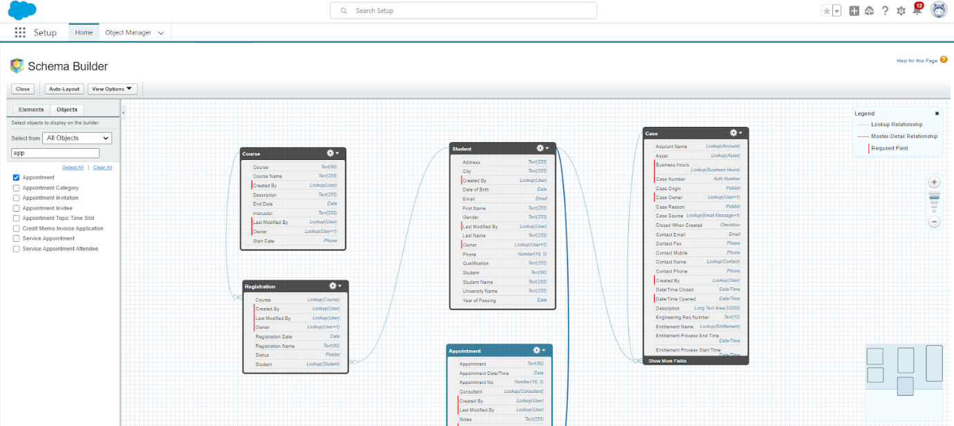

* **Configured the Case Object**

The Case object was customized to handle immigration cases, consulting requests, and other service inquiries. Fields and picklists were added to track case types, statuses, and priority levels, supporting effective case management.

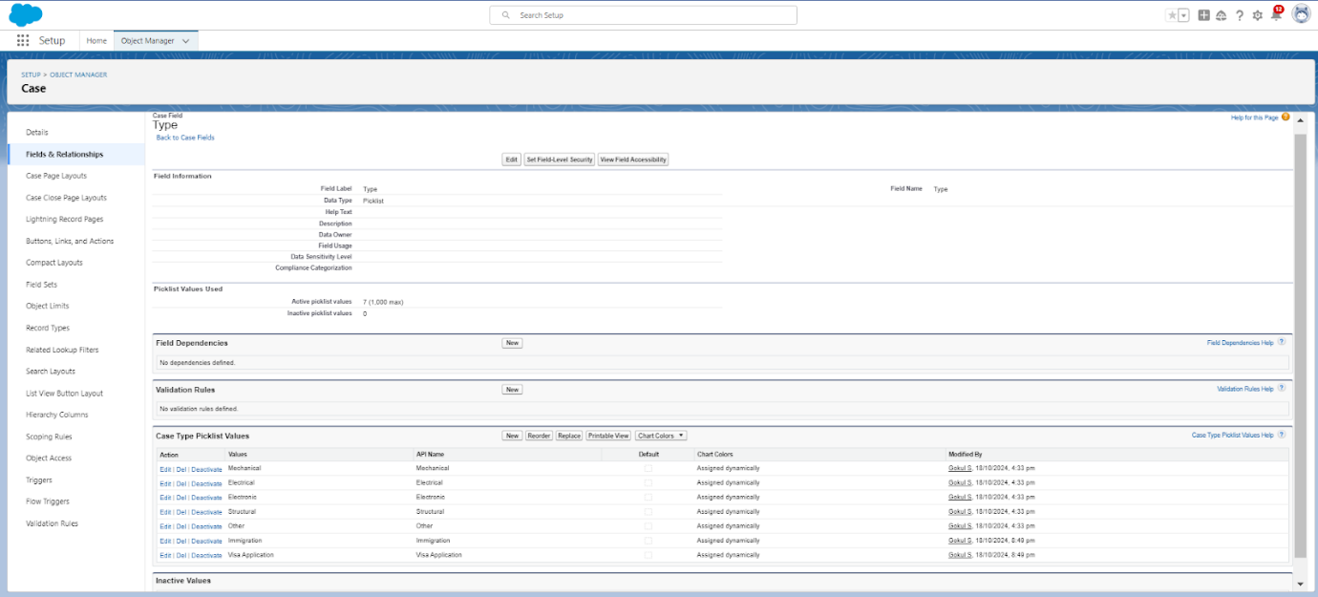

* **Created a Lightning App**

A custom Lightning App was developed to bring together the institution’s service modules, providing users with easy access to Admissions, Consulting, and Immigration Case Management in a unified interface.

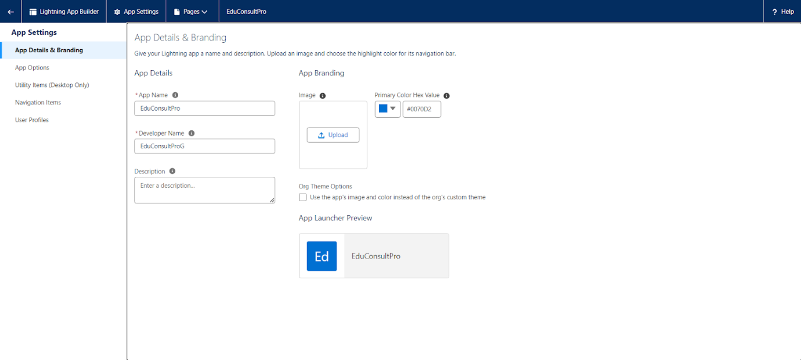

* **Added Screen Elements for User Interaction**

Various screen elements were added to capture student information and display relevant data. These elements included forms for admissions, consulting requests, and appointment scheduling, enhancing the app's interactivity.

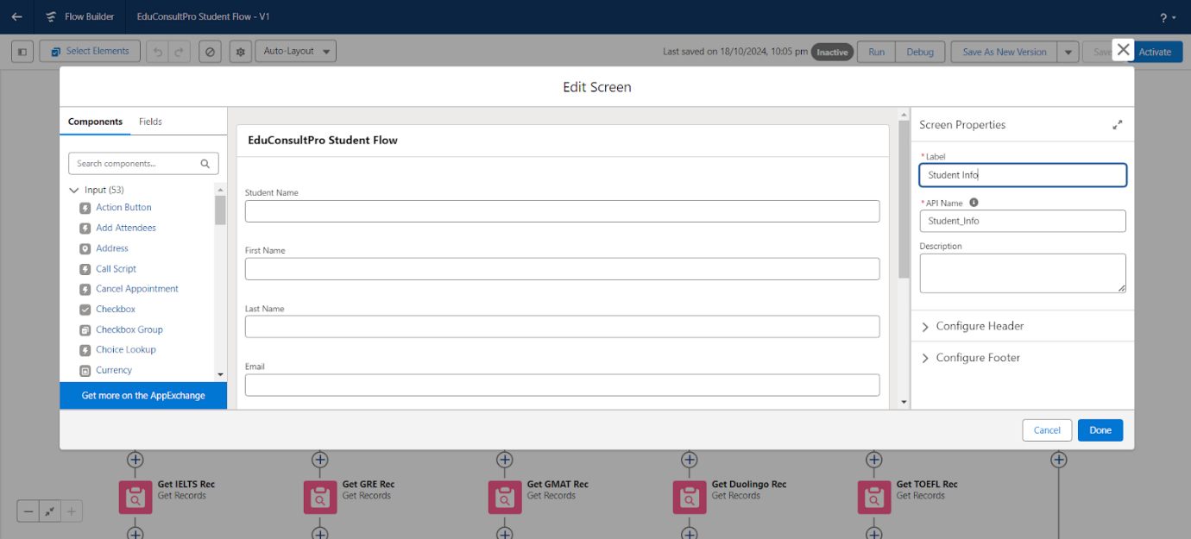

* **Created a Student Record Using the Create Element**

A Student record was created using the “Create Records” element within a Flow to capture prospective students’ details directly into Salesforce upon form submission.

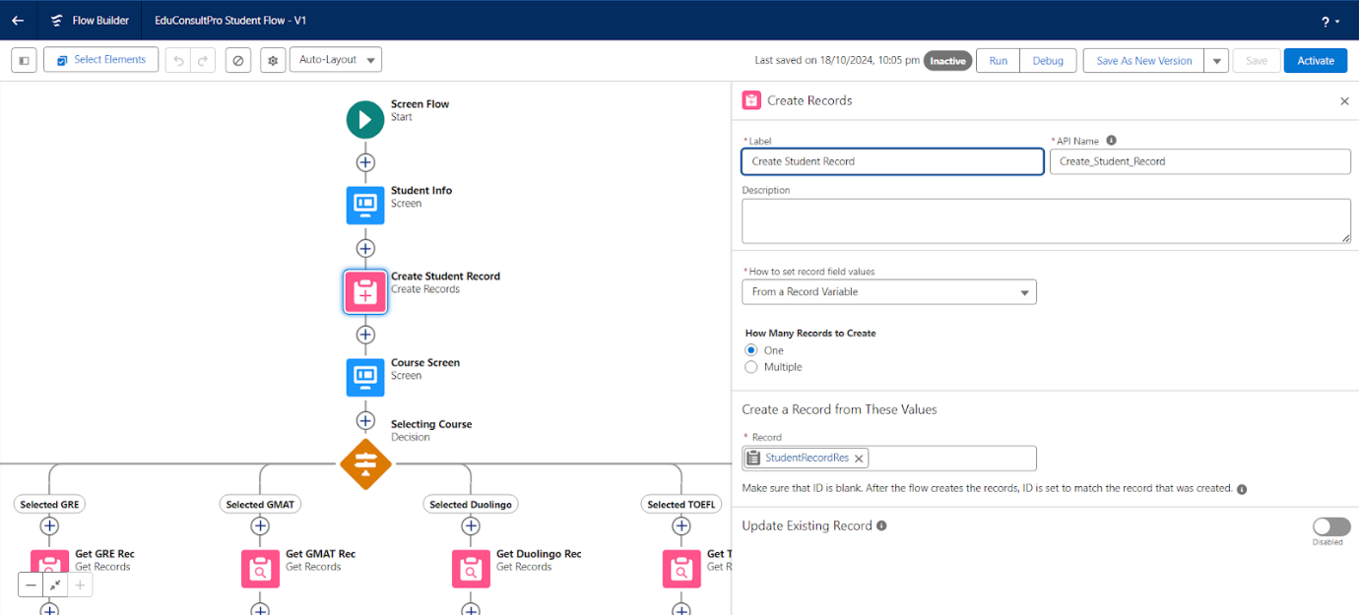

* **Added Decision Elements for Conditional Logic**

Decision elements were added to guide the Flow based on specific criteria. For example, different paths were taken based on application status or consulting preferences, improving the Flow’s responsiveness to various conditions.

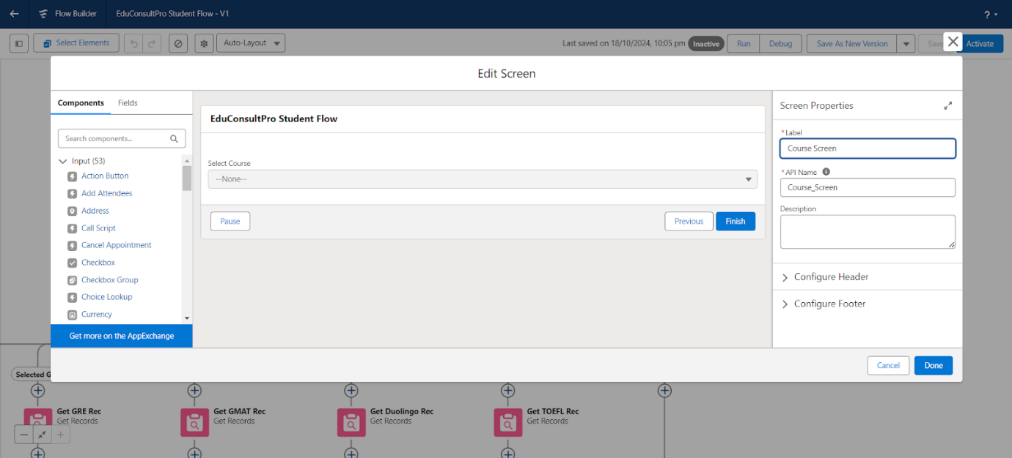

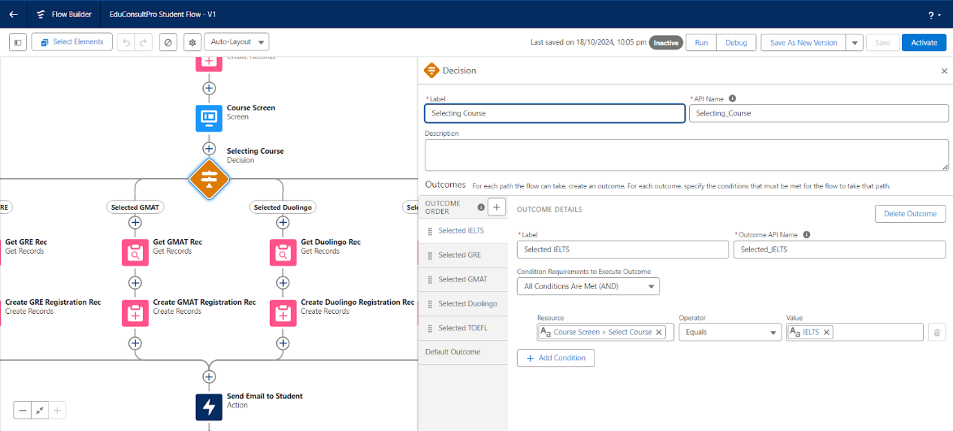

* **Added GET Record Elements to Retrieve Data**

GET Record elements were used to fetch existing records, such as student profiles or course information, enabling pre-filled data fields in forms and quick access to related data. 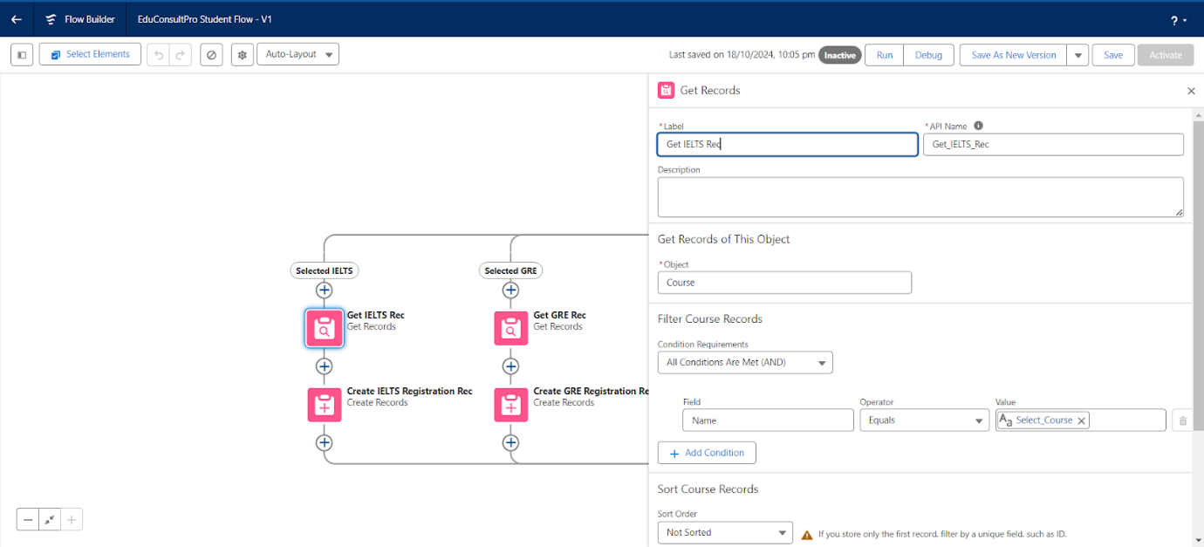

* **Created a Registration Record Using the Create Records Element**

Registration records were created to link students with their chosen courses. This allowed admissions and consulting staff to monitor enrollment and track progress through the system.

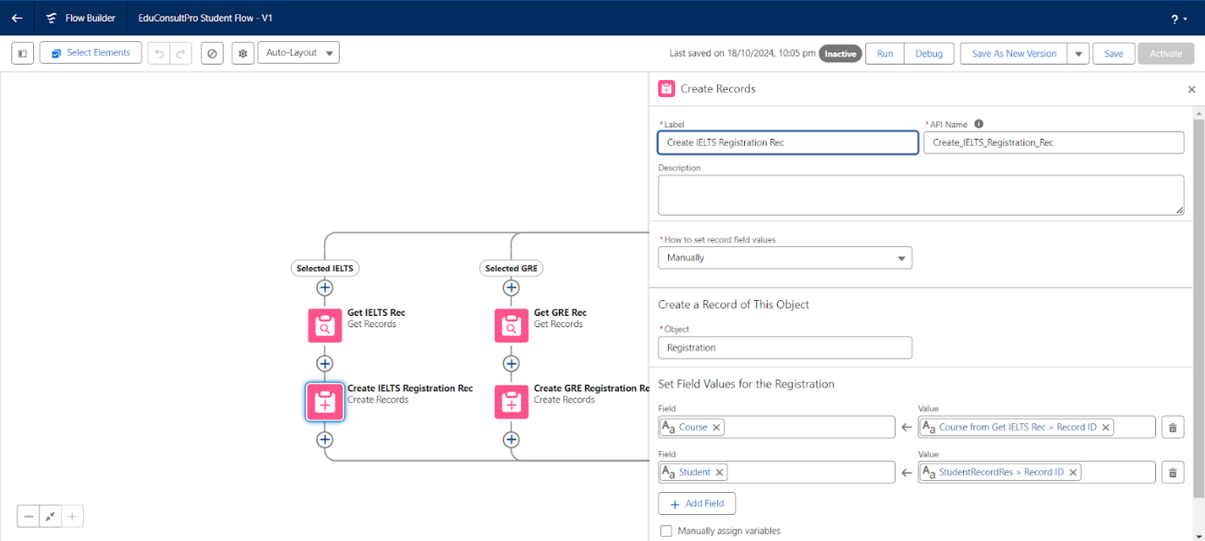

* **Created Email Text Template Variables for Email Body and Subject**

Email template variables were set up to personalize communication with students, enabling automated emails with custom subject lines and body text based on application status or case updates. 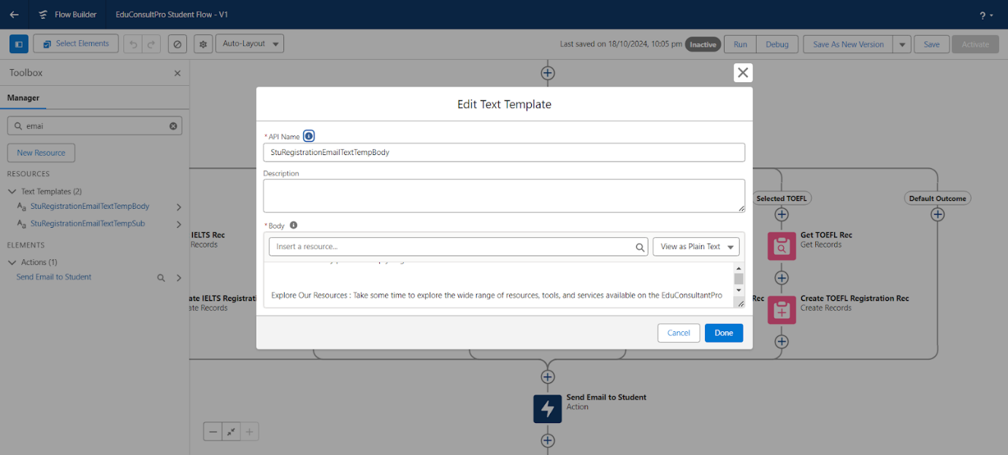

* **Added Action Elements for Task Automation**

Action elements were configured to send email alerts, update records, or create tasks within Salesforce. For example, notifications were sent to students and staff when consulting requests were submitted or approved. 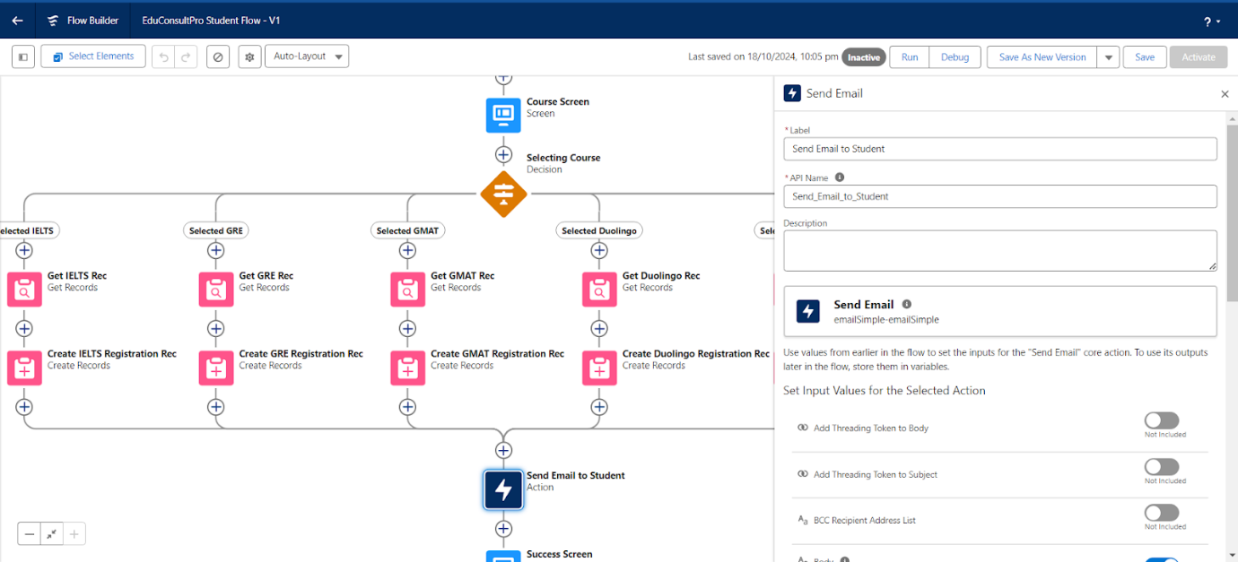

* **Configured User Settings**

User roles, permissions, and profiles were configured to control access levels. Specific settings allowed admissions staff to manage applications, consultants to view requests, and immigration agents to process cases securely.

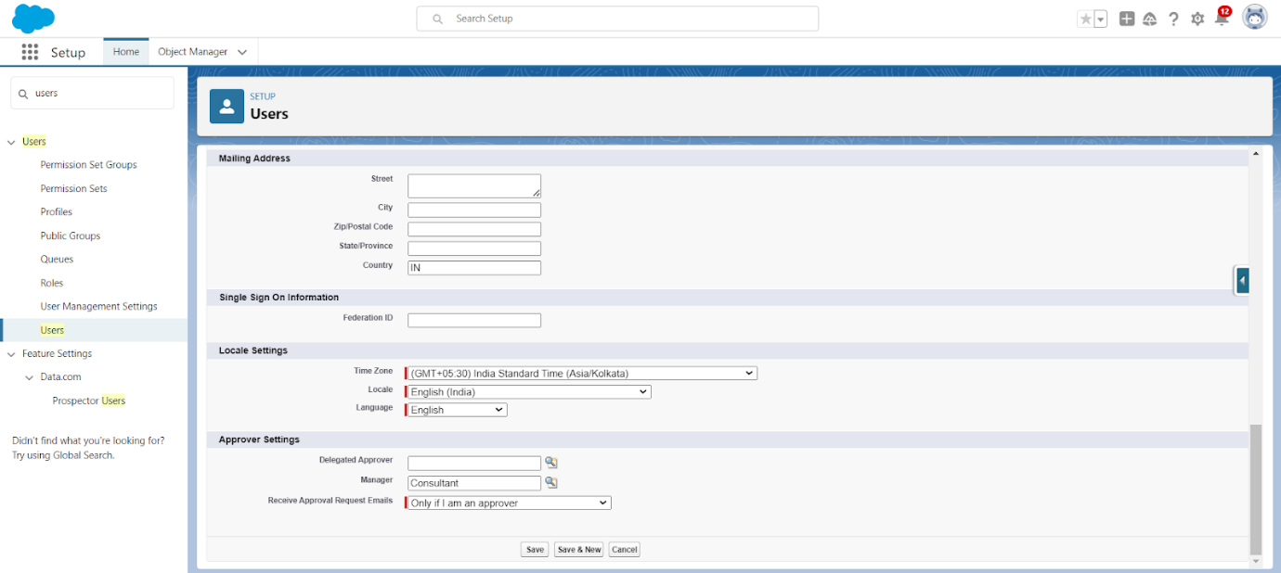

* **Created an Email Template**

Email templates were created to standardize communication for admissions, consulting, and immigration cases. Each template was tailored to provide relevant updates to students and staff efficiently.

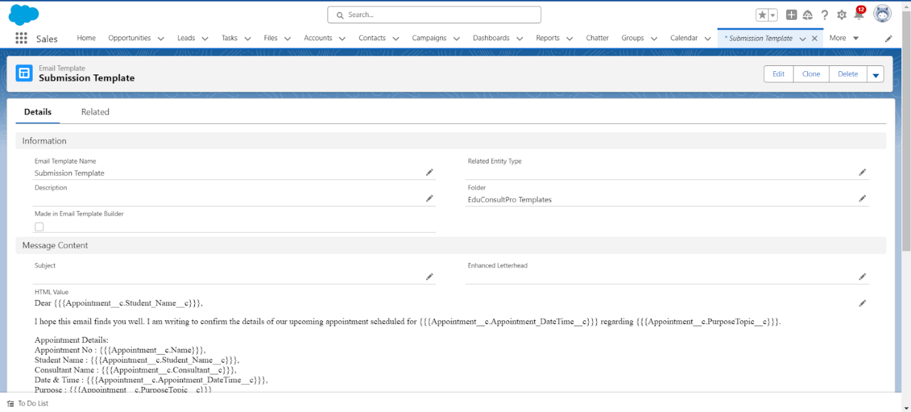

* **Created an Approval Process**

A multi-step approval process was created for consulting requests, with automated email notifications at each stage. Requests were routed for approval or rejection based on predefined conditions, ensuring a structured review process.

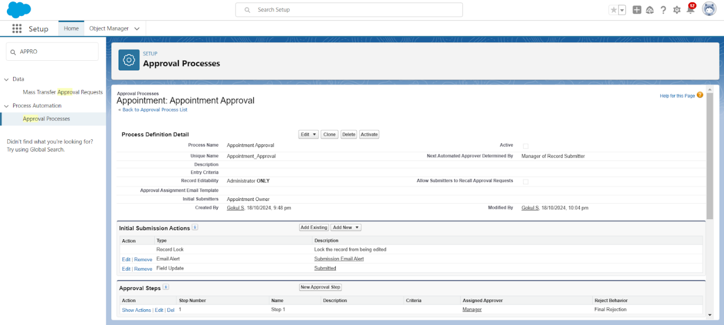

* **Configured the Start Element for Flows**

Start elements were configured to initiate Flows upon form submissions, capturing student information and creating associated records instantly in Salesforce.

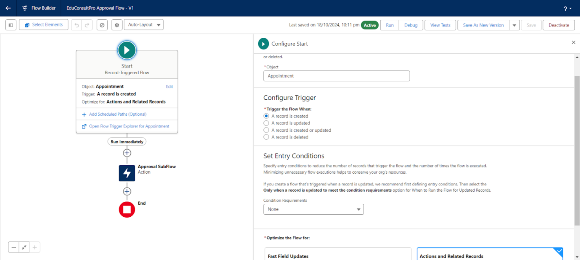

* **Created an Appointment Record Using the Create Records Element**

Appointment records were created to manage consulting schedules within the CRM. Fields for appointment date, time, and status enabled staff to track and update appointments seamlessly. 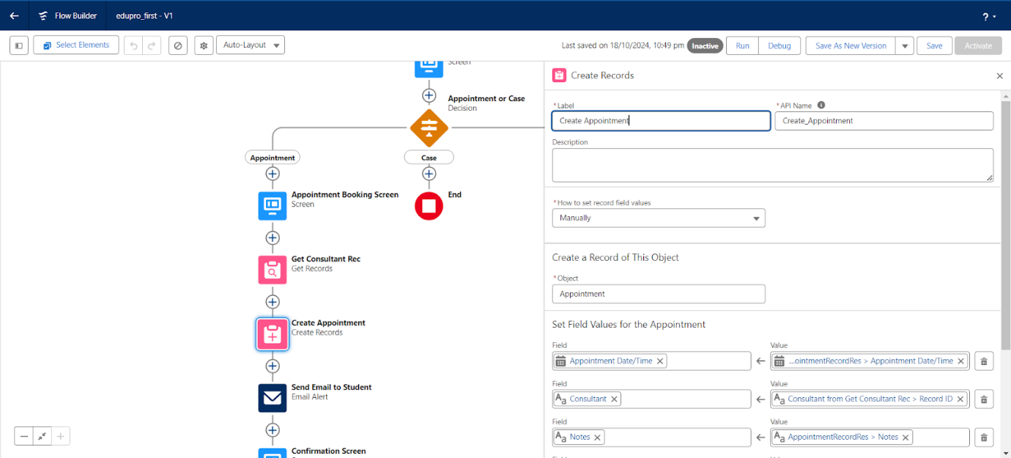

* **Added a Subflow Element for Modular Processes**

Subflow elements were included to modularize repetitive tasks, such as student registration and case tracking, within Flows. This approach improved process organization and reduced redundancy.

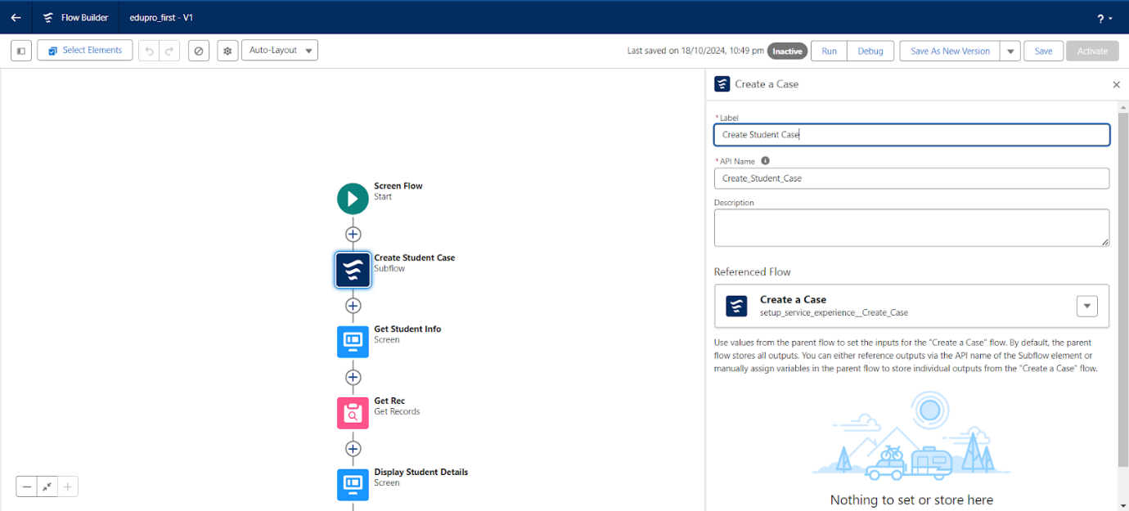

* **Created a Lightning App Page**

A custom Lightning App page was developed to serve as a dashboard, displaying key information such as open cases, upcoming appointments, and new consulting requests. This centralized view facilitated efficient task management. 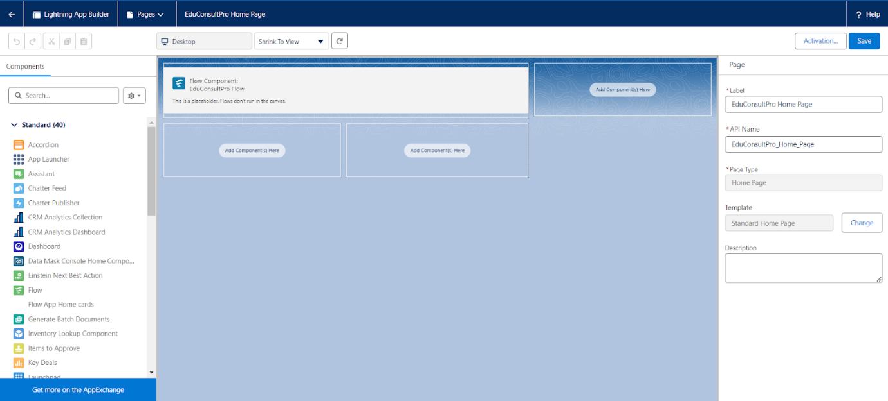

* **Added Multiple Screen Elements for Enhanced User Interaction**

Additional screen elements were incorporated throughout the project to guide users through form completion, record viewing, and case updates, enhancing the overall user experience within the Lightning App. 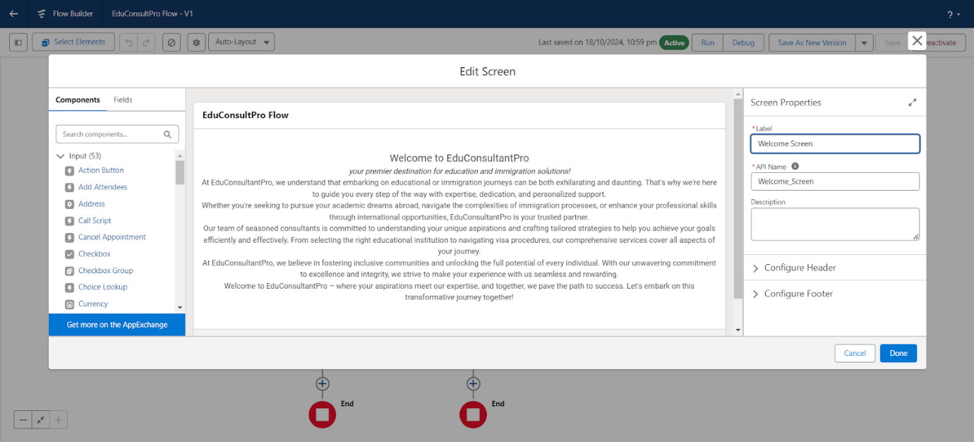

* **Added Decision Elements for Advanced Routing**

Further decision elements were added to handle complex routing scenarios. For example, consulting requests were directed to specific advisors based on expertise, and immigration cases were assigned based on case type.

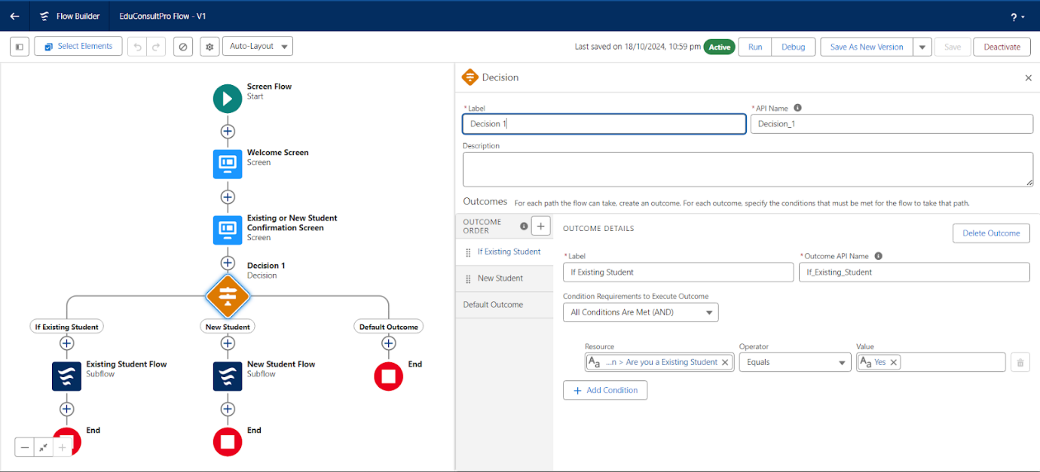

* **Added GET Record Elements for Enhanced Data Retrieval**

Additional GET Record elements were added to retrieve detailed information from related records, such as consulting preferences and immigration case details, improving data accessibility and form pre-filling. 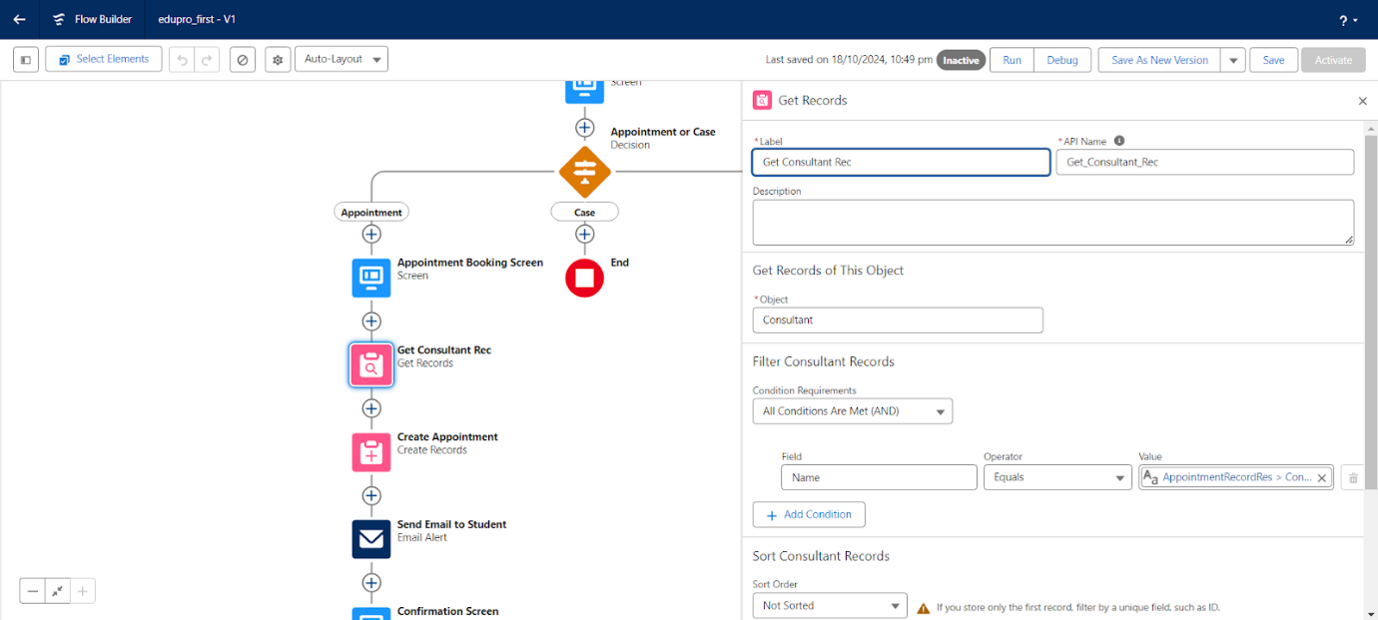

1. **Testing and Validation**
   1. **Unit Testing (Apex Classes, Triggers)**

**Apex Trigger:**

trigger ConsultingRequestTrigger on Consulting_Request__c (before insert) {

for (Consulting_Request__c request : Trigger.new) {

request.Status__c = 'Pending Review';

}

}

**Test Class:**

@isTest

private class TestConsultingRequestTrigger {

@isTest

static void testConsultingRequestTrigger() {

Consulting_Request__c request = new Consulting_Request__c(Name = 'Test Request');

insert request;

Consulting_Request__c result = [SELECT Status__c FROM Consulting_Request__c WHERE Id = :request.Id];

System.assertEquals('Pending Review', result.Status__c, 'The Status field should be updated by the trigger.');

}

}

### 

### 

### STEPS :

1. **Created a Test Record:**
   * Created a "Consulting_Request__c" record with a sample name, e.g., "Test Request."
2. **Inserted the Record:**
   * Inserted the record to trigger the **ConsultingRequestTrigger**.
3. **Verified the Update:**
   * Queried the "Status__c" field of the newly created record to check if it was updated to "Pending Review" as per the trigger logic.
4. **Executed the Test in Salesforce:**
   * Navigated to **Setup > Apex Test Execution**.
   * Selected the TestConsultingRequestTrigger test class.
   * Clicked **Run** to execute the test.
5. **Validated the Results:**
   * Ensured the test passed successfully, with assertions confirming the "Status__c" field value was correctly updated to "Pending Review."
   1. **User Interface Testing**

User Interfaces have been tested with various types of data and edge cases.

**Verify Layout:**

* Ensured the **Lightning App Dashboard** for Admissions, Consulting, and Immigration Case Management loaded correctly, displaying all components such as metrics, charts, reports, and tables without layout issues.
* Confirmed that key visual elements like status indicators, notifications, and action buttons were properly aligned.

**Check Data Accuracy:**

* Validated that displayed metrics and data, such as the number of pending admissions, consulting requests, and resolved immigration cases, matched the source records in Salesforce.
* Cross-checked application statuses, consulting requests, and case details for consistency across different modules.

**Test Filters:**

* Verified that filters in dashboards and lists (e.g., by student status, department, or application date) updated the displayed data dynamically.
* Tested the responsiveness of multi-select picklists and other filter components for accurate functionality.

**Check Interactivity:**

* Confirmed that all clickable elements, such as charts, links, and buttons, performed the expected actions, such as navigating to detailed records or triggering workflows.
* Verified functionality of interactive forms for submitting admissions and consulting requests, ensuring data integrity and validation.

**Test Responsiveness:**

* Tested the CRM’s user interface across multiple devices:
  + **Desktop:** Verified that all modules, including dashboards, record views, and forms, displayed optimally on large screens.
  + **Tablet:** Ensured proper scaling and interaction for medium-sized screens, including touch functionality.
  + **Mobile:** Confirmed mobile responsiveness for accessing the CRM on smaller devices, ensuring forms, dashboards, and notifications were accessible and legible.

1. **Conclusion**

Summary of Achievements:  
The CRM project successfully transformed institutional service management through Salesforce, achieving significant operational and service delivery milestones:

1. **Enhanced Efficiency and Automation**: Key processes, including admissions, consulting, and immigration case management, were automated, reducing manual work and streamlining workflows. Automated notifications and approvals helped staff respond swiftly to student needs.
2. **Improved User Experience**: The user-friendly Lightning App and customized screens provided students and staff with an intuitive interface for form submissions, case tracking, and appointment scheduling, significantly enhancing user satisfaction.
3. **Data-Driven Insights and Reporting**: Custom reports and dashboards enabled data-driven decision-making, allowing administrators to monitor application trends, consulting demand, and case resolutions in real-time, supporting better planning and resource allocation.
4. **Secured and Compliant Data Management**: Role-based access, approval workflows, and document management features ensured that sensitive student information was securely managed, fostering trust and ensuring compliance with data privacy standards.

Overall, the CRM solution empowered the institution to deliver responsive, personalized services while maintaining high standards of security and operational efficiency, aligning with its mission to support student success.